Programming 6211 Assignment 1

2016

Adrian Beukes 15002426

**Content**

Specifications ………………………………………………………………………..2 Purpose Functional Requirements

Documentation ………………………………………………………………………..3

Test Data ………………………………………………………………………..4

Error Handling …………………………………………………………………….....6

Help ………………………………………………………………………..6

Feedback ………………………………………………………………………..7

Improvements ………………………………………………………………………..7

**Specifications:**

Purpose:

This project is to do a stock system for a store. The store I choose was an extreme sports store. The main features of the program is to allow the user to browse through the category’s and choose which one they would like to view, once you selected a category you will be able to view the products they have in their store available, and to order more in the case where the stock might be low. Added feature, are the functions where the user can also see stock from the start of the month, and how many were sold during the month.

My program works on a console application, where it would receive input from a user, and use that input to give the wanted outcome/reports.

Functional Requirements:

In my code you will find usage of the following:

* Methods calling and creating
* 2d Array’s
* If...else statements
* While loops
* User input
* Advance if statements
* Try…catch
* Error handling
* Converting
* Randomize
* String manipulation
* Console clearing

**Documentation**

Flow Chart:

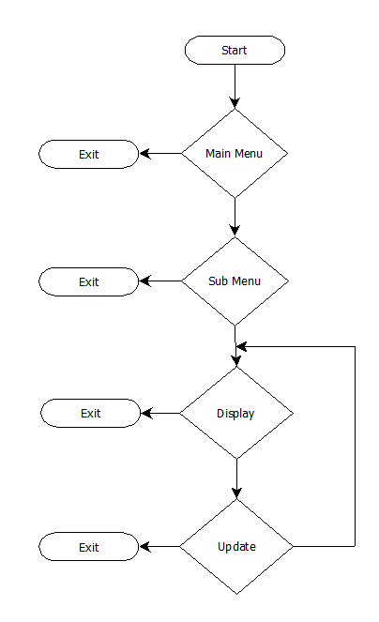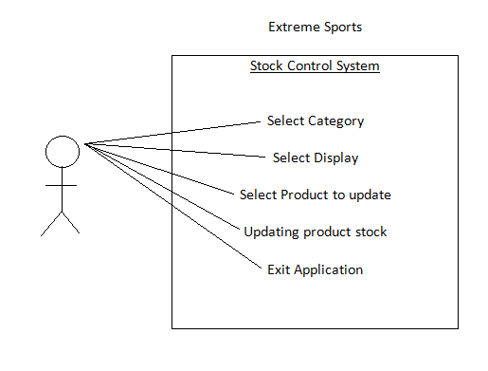

Class Diagram

User

**Test Data**

A few screenshots of my program will follow, with explanation of what’s happening at each stage, as I progress in order to test it:

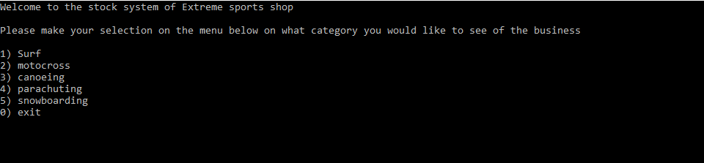

This is the main menu, you can choose which category you would like to see, or exit program.

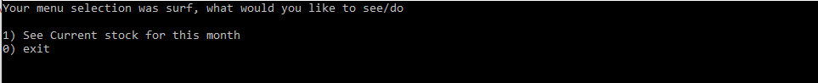

This is the sub menu, you have a choice of seeing the stock from your previous selection, and in the stock you will also be doing the updating

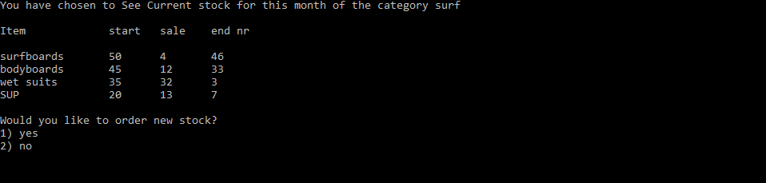

This is the report for all your stock in that category; you can then have the option of ordering more, or exit the program

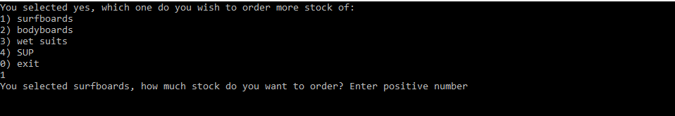

If you do decide to order more, it gives the option on which item to order, and then ask the amount you would like to order

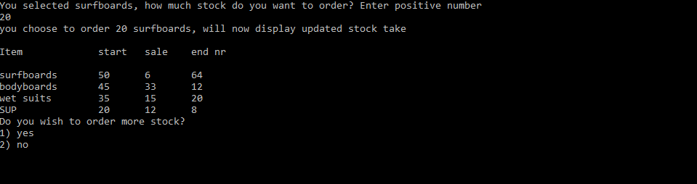

After you successfully placed the order, it will show the updated stock report, and ask if you want to update anything else, and repeat the loop



If you do say no, it will bring up message thanking you for using the program, and a function to press any button in order to exit the application

**Error Handling:**

For my error handling I added Booleans with while loops, so in case the incorrect information was entered, it will repeat asking the question

I also added a try catch for wrong input, and In this case, it will send you back to the main menu

There was also if statements used to check that values entered for ordering are always positive, which will show you an error message

**Help:**

This is a guide that would take you step for step through the application.

On opening the application, you will find yourself with the main menu, where you will have the option of selecting a category, in case you do select or enter wrong data, you will be notified.

When you selected the category you would like to view, a new screen will give you with the option to view the products of that category or to escape.

If you selected to view the products, a new menu will be displayed with all the products and available stock that you can find inside each, on this screen, you have the option to update any of the products and add more stock if you find that one of them is low

This will take you to another screen where they will make a confirmation on the selected product, and with how much you would like to update it with

After you enter an amount, there will be confirmation, and it will take you automatically back to the display screen, where you can view the updated stock, and you have the option of updating any of the other stock, and repeat the process or exit

Upon pressing the exit key, you will be ask for confirmation, and a thank you will appear, as you leave the program.

**Feedback:**

On this assignment I received feedback of improvements I need to make for assignment 2

The major issues involved:

* Redundancy of code lines
* Only using one class, need to add more
* Naming of variables

**Improvements:**

For my assignment 2 I aim to improve my project by looking at code redundancy and how to minimize it, ass2 will be on forms, so I can work on having multiple forms instead of just 1.

I will also focus on renaming all default names of toolbox items that I added and form names etc.

I have plans to improve my application by adding more functionality, like having an back button

I will also improve security by adding a log in Password screen.